BDSE-0922-113_Francis Roel L. Abarca BDSE07-UIF

Music Store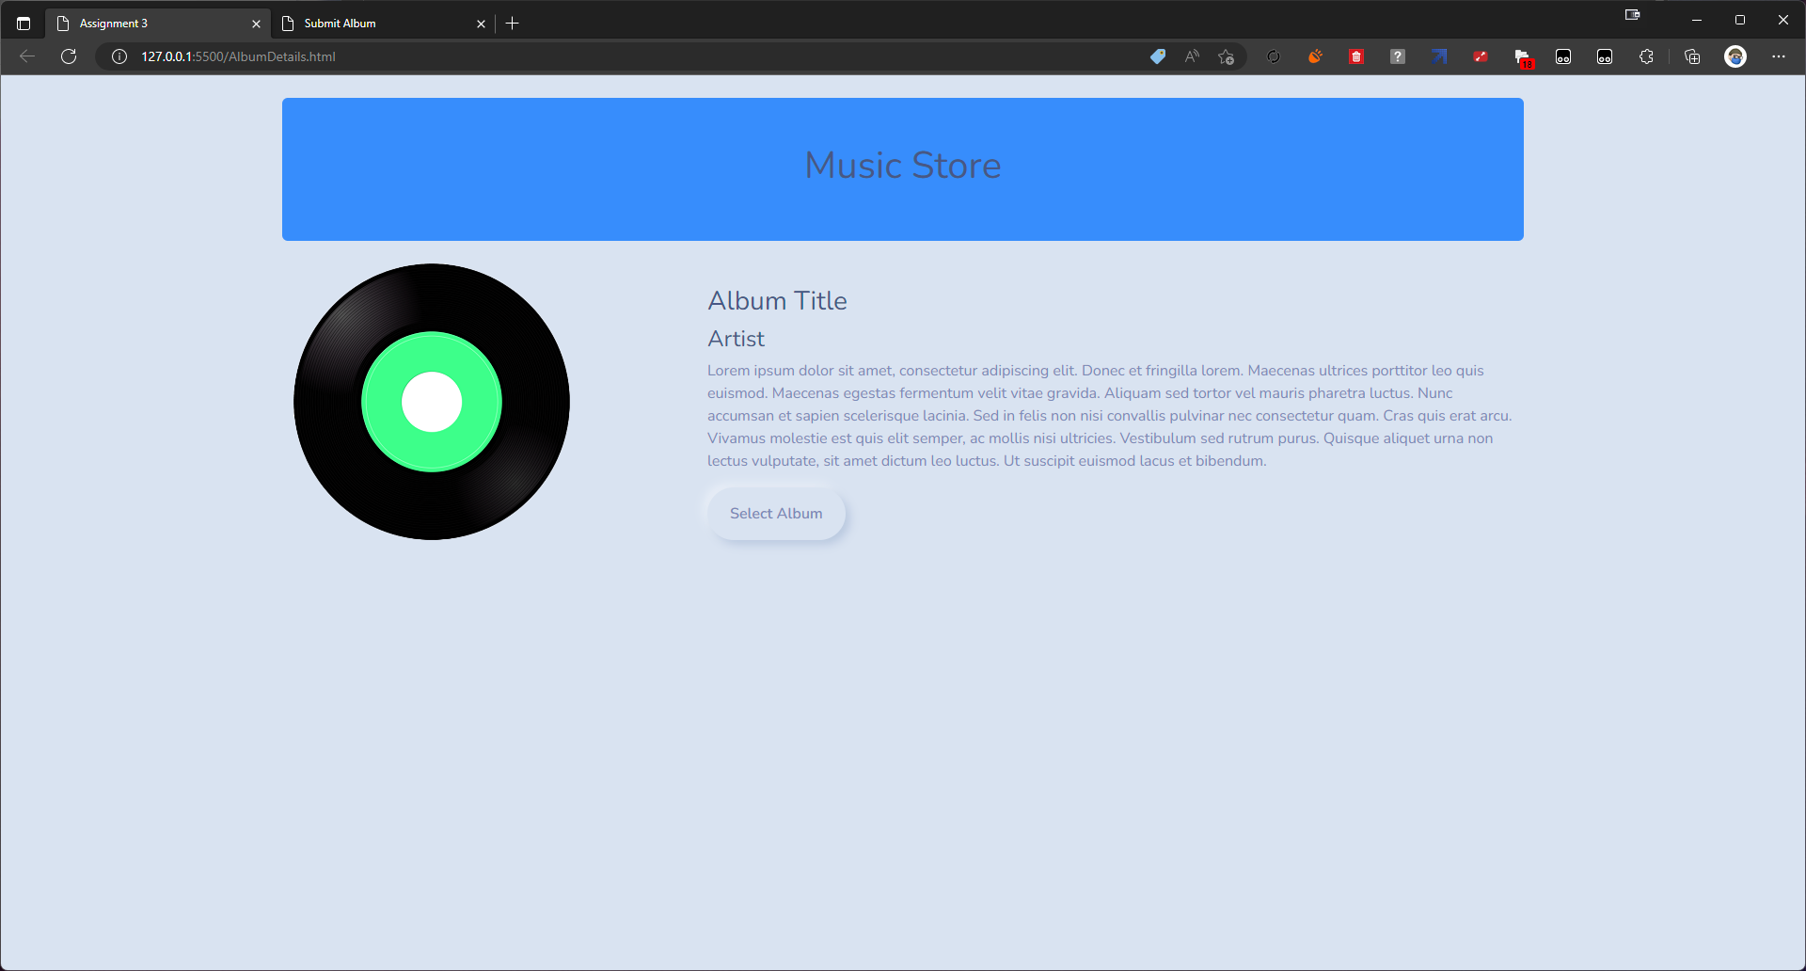

Submit Album (Album Title and Artist)

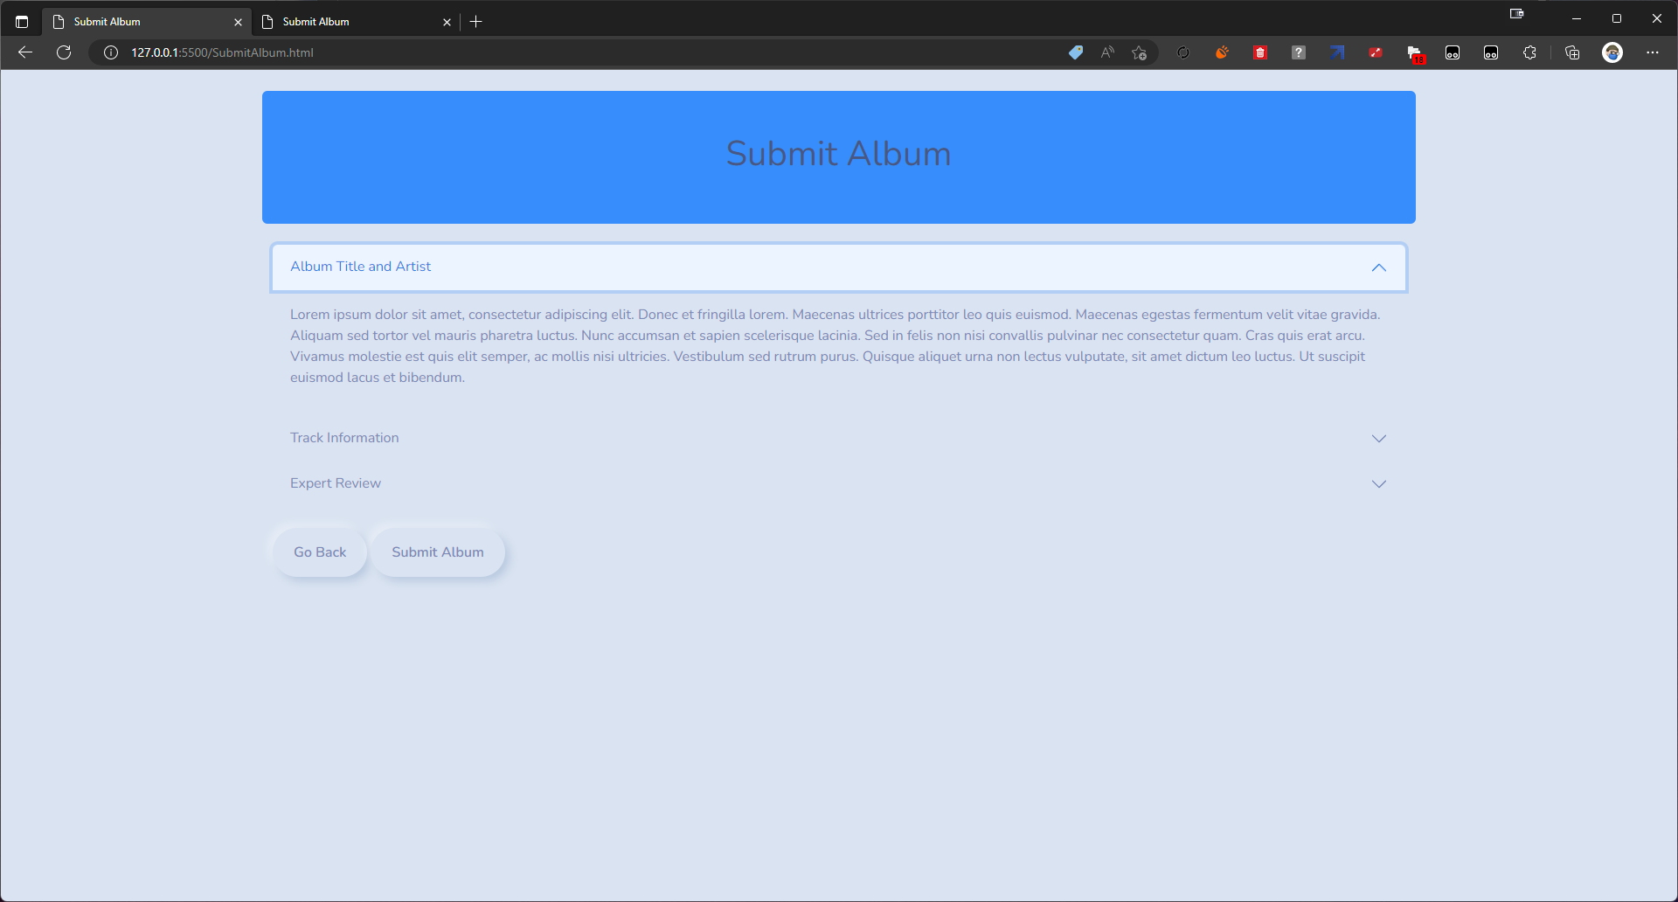

Submit Album (Track Information)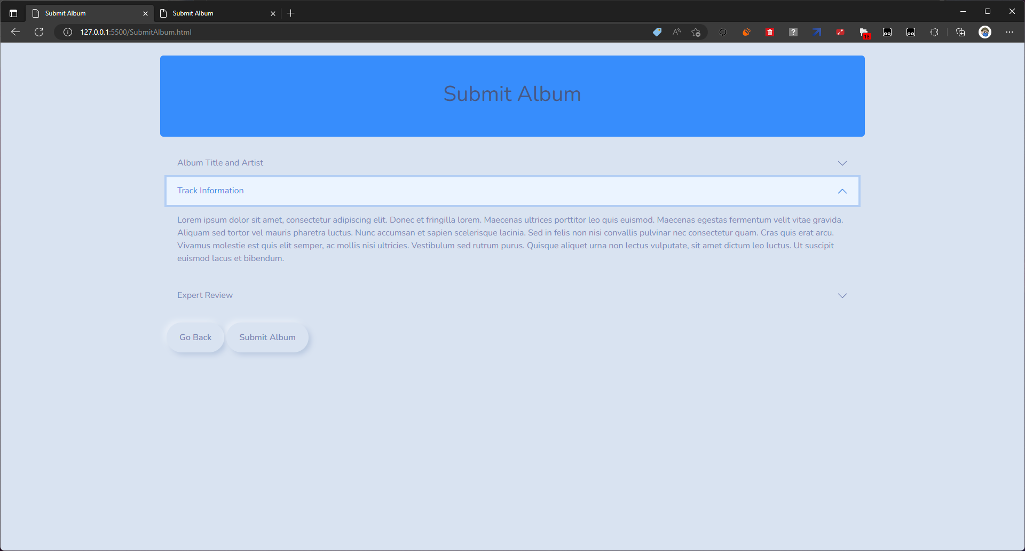

Submit Album (Expert Review)

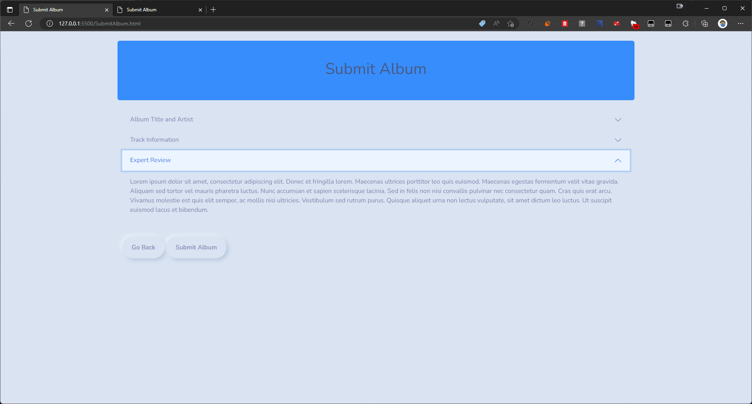

Confirm

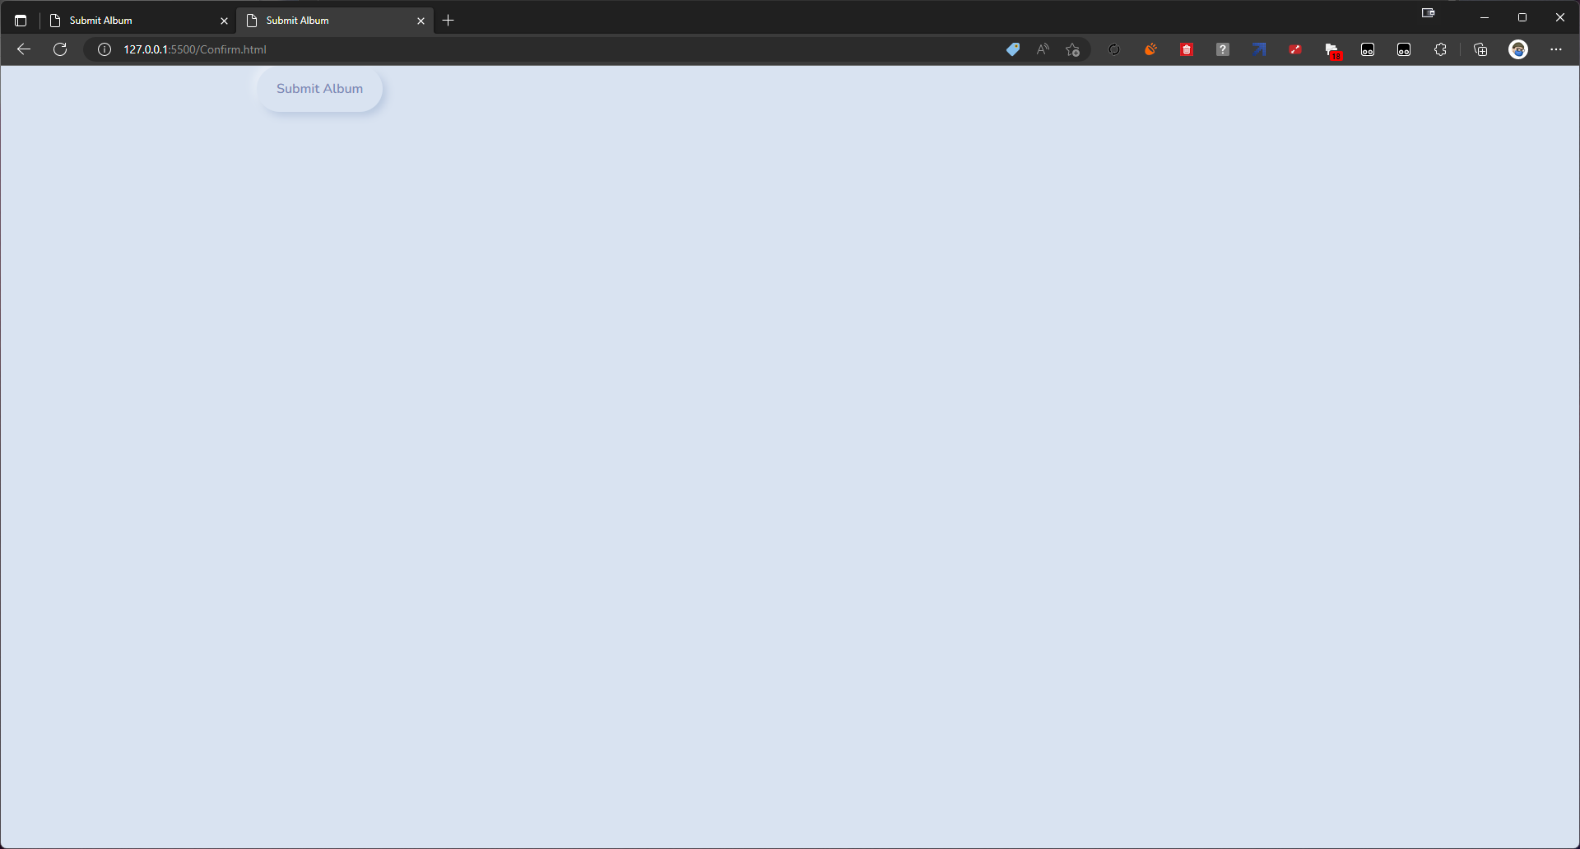

Confirm Dialog Box

